Release for Medical Treatment
Name:__________________________
Date:___________________________
List any conditions that physicians should be aware of:
________________________________________________________________
I hereby authorize any medical treatment, which may be advised or recommended by a physician. Also, I waive and release the camp staff, North Davidson Administration, and the Davidson County School System from all rights and claims for damages, injuries, or loss to person or property which may be sustained during participation in camp.
Parent or Guardian Signature:
________________________________
Date:___________________________
“It’s a beautiful day. Let’s play ball!”
29th Annual
No Excuses Baseball Camp at ND
Of Welcome Supports
The Knights
2024 No Excuses
Baseball Camp at
North Davidson

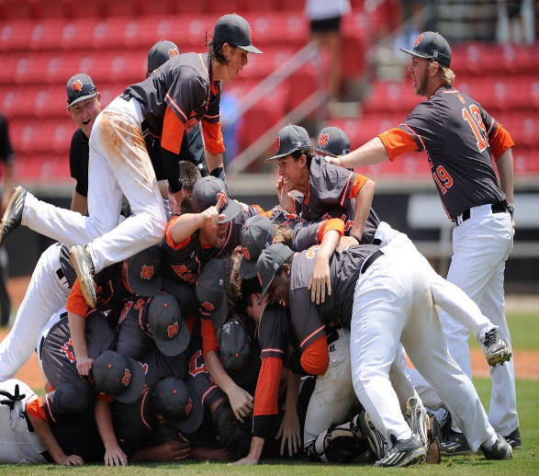
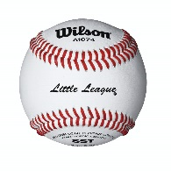
Camp Dates
June 17-20
Ages 7 – 15
9am-12 noon
Monday – Thursday

No Excuses
Baseball Camp

The Black Knight’s Baseball Staff is excited about the camp for this year. This is our 29th year working with our young players and each year gets more gratifying.
We will emphasize fundamentals, skill development, team play and most of all fun! Come learn the game with one of the finest camp staffs around.
Sign up now and reserve your spot.
Camp Information
Date: June 17 – 20

Time: 9am – 12 noon

Location: North Davidson
Baseball Field

Cost: $100.00

Ages: 7 – 15

Staff: Matt Griffin – Head Coach,
North coaching staff,
current and former North
players and area coaches.

Extras: Each camper will receive
a T-Shirt and snack

Registration: 8:00 am June 17 or
Pre-register by mail
Questions: Matt Griffin
336-972-8027
mgriffin1@davidson.k12.nc.us

Registration Form

Name: _____________________
Age: ___ School: _____________
Date of Birth: ________________
Address: ____________________
____________________
Parent Name: _______________
Home Phone: _______________
Work Phone: ________________
E-Mail: _____________________

Check Payable to: Black Knights
Baseball Camp

Mail to: Matt Griffin
4226 Frye Bridge Rd.
Clemmons, NC 27012

T-Shirt Size:
Adult S __ Youth S __
Adult M __ Youth M __
Adult L __ Youth L __
Adult XL __

